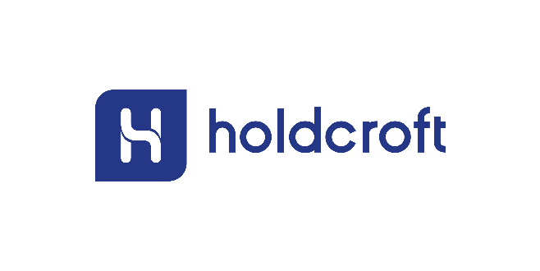

**Gender pay gap report April 2019**

The Holdcroft Motor Group is comprised of a number of different limited companies, this report looks at the gender pay gap across the consolidated group. The group does not have any entities that individually employs more than 250 people so these are not detailed separately to this report. The consolidated Holdcroft Motor Group employed 626 “relevant employees” at the snapshot date of 5th April 2019.

The Automotive Retail Sector has historically always been a very male dominated industry at most levels of the business. It is therefore no surprise that when we take a snapshot of our organisation we have a much greater proportion of male employees (74%) than female (26%). This is again a small improvement on previous years and we continue to actively encourage more female employees into the industry.

We have through the year seen an increase in female representation in our sales teams to 22% which is only a 1% increase on 2018 but 3% on the 2017 position so definite positive steps. There has been a small reduction in the percentage of female employees in our senior management team, representation is now at 12% versus 14% in 2018 and back to the same level as in 2017.

There is still a disproportionate amount of male employees in the organisation as a whole so we are not surprised that this delivers a pay gap of 12.04% (Mean Ave) and 6.97% (Median Ave).

These figures do show an improvement versus 2018 and we will continue to provide a working environment that promotes equality and encourages all of our employees to strive to succeed with the knowledge they will be rewarded based on their efforts and achievements, gender does not factor within that decision.

The remuneration packages within all of our departments are the same for both male and female employees and the only differences in earnings are based purely on individual performance.

We expect that over the coming years the numbers of female applicants within the industry will continue to gradually increase and we strive to encourage this growth within our own organisation through our recruitment policy.

The Holdcroft Motor Group and its subsidiaries are equal opportunities employers and are dedicated to meeting their obligations under the Equality Act 2010. Appointments made to our organisation are based on the merits of the individuals that apply for positions and we always look to employ the “best person for the job” regardless of gender.

**Gender pay gap explained:-**

A pay gap is the difference in average pay between two groups within a workforce. It is not to be confused with equal pay which is concerned with individuals being paid equally for the same or similar types of work. The information given in this report concerns the pay gap between male and female employees within the workforce of the Holdcroft Motor Group.

|  |  |
| --- | --- |
| Difference in mean hourly rate of pay | 12.04% |
| Difference in median hourly rate of pay | 6.97% |

The mean gender pay gap is the difference in average hourly rates of pay that female and male employees receive. This gives an overall indication of the gender pay gap by taking all hourly rates of pay and dividing by the total number of employees in scope.

The median gender pay gap shows the difference in the midpoints of the ranges of hourly rates of pay for men and women by ordering individual rates of pay from lowest to highest and comparing the middle value.

Both mean and median gender pay gap is expressed as the difference in the average pay of all male and female team members across the Holdcroft Motor Group as a percentage of men’s pay

The mean and median pay gap is reflective of the high proportion of male employees within our sales teams and at senior level. This gap will continue to exist until those numbers become more equal. The Holdcroft Motor Group does encourage females to apply for roles within all areas of the business and they are considered equally with all applicants by their ability, experience and performance.

|  |  |
| --- | --- |
| Mean bonus pay gap | 65.53% |
| Median bonus pay gap | 14.79% |
| Proportion of Males receiving a bonus | 68.75% |
| Proportion of Females receiving a bonus | 35.19% |

The Holdcroft Motor Group operates with a number of bonus schemes throughout the organisation to encourage strong performance from its employees as well as a strong focus on customer service. This is reflected with more that 60% of the overall workforce receiving a bonus.

A high proportion of our overall female employees (61%) are employed within administration roles which are generally salaried roles and not commission / bonus based. When we look at the Administration area in isolation of the 127 total employees 99 are female which is 78% of that group.

The data below highlights the disparity between the number of male and female employees in the sales and senior management positions.

TG Holdcroft Holdings Ltd is committed to employing the best candidate for the role in all areas of the business and actively encourages females to apply for those roles in both sales and senior management.

The charts below highlight the under representation of female team members in senior roles across our organisation as shown by the lowest percentage of females in the upper quartile.



I confirm the gender pay gap data contained in this report is accurate.

Darren Holdcroft

Managing Director

Holdcroft Motor Group